Credit Shield System Overview

6th March 2014

**CREDIT SHIELD PROCESS AT RMT**

|  |  |
| --- | --- |
| PVN | PRUFC |
| 3. Insurance Group  4a. Wait for further information  No  4. Valid?  Yes  5. Issue insurance contract  7. | 1. Credit shield at Branch  5. Wait insurance contract  4b. Pending            6. RMT send insurance contract to customer including loan agreement documentation |

**REQUIREMENT FOR RMS_2**

**I/ Loan Status:**

Insurance Certificate waiting

RMT received

Fresh loan

Branch sends RMT RMT sends

Cr/S AT RMT

To RMT receives to PVN

Pending

Failed

Insurance Certificate failure

Pass

Update

* **Fresh loan:**

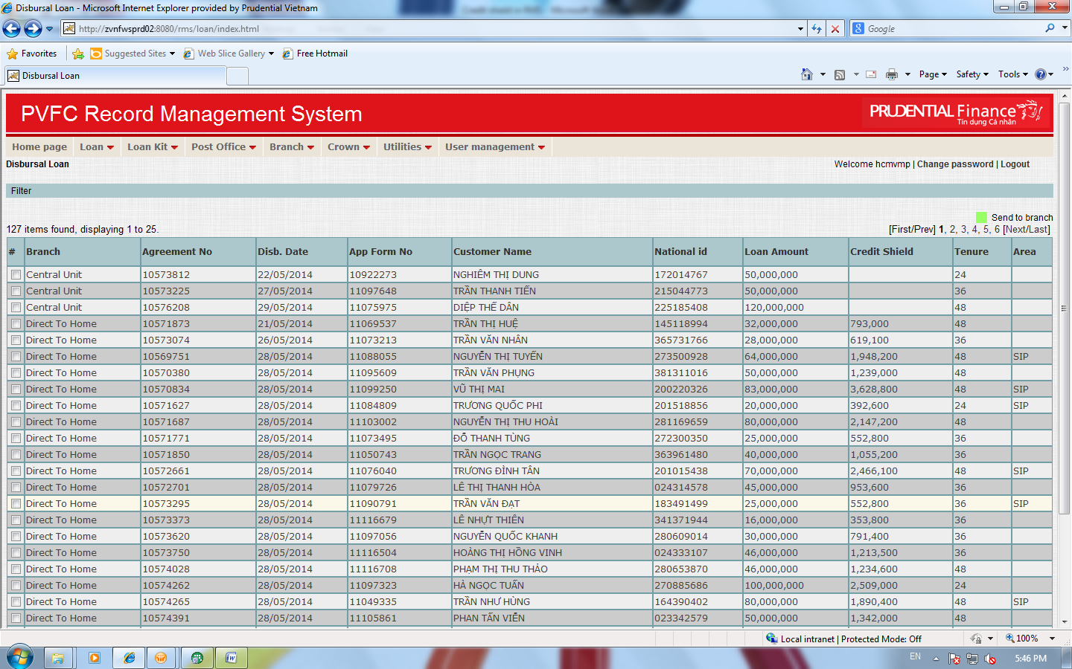

* **Cr/S at RMT:**

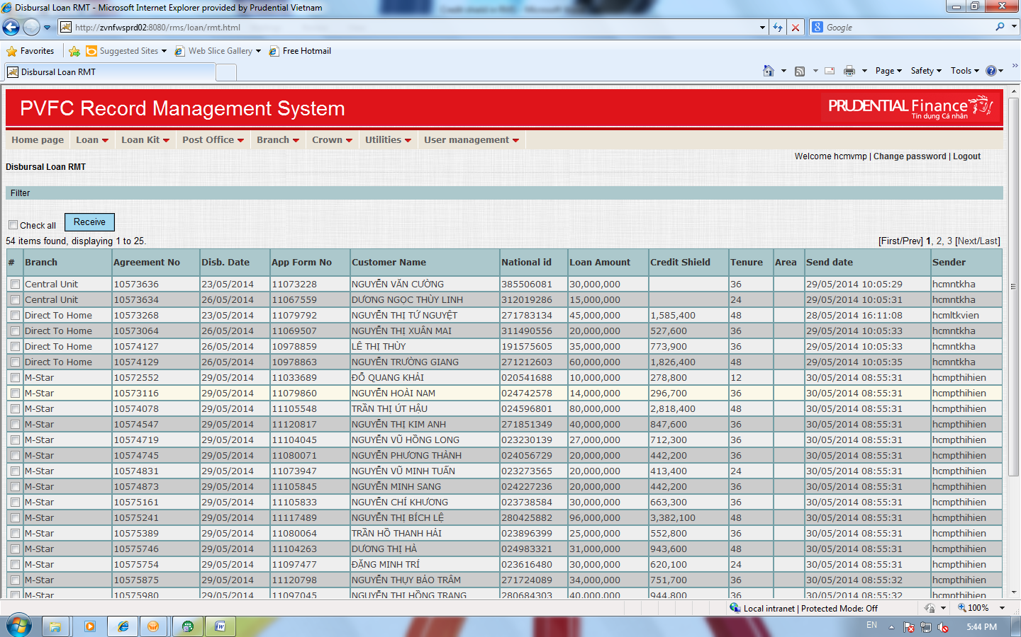

* **RMT received:** At this stage, RMS2 don’t show Category and Note

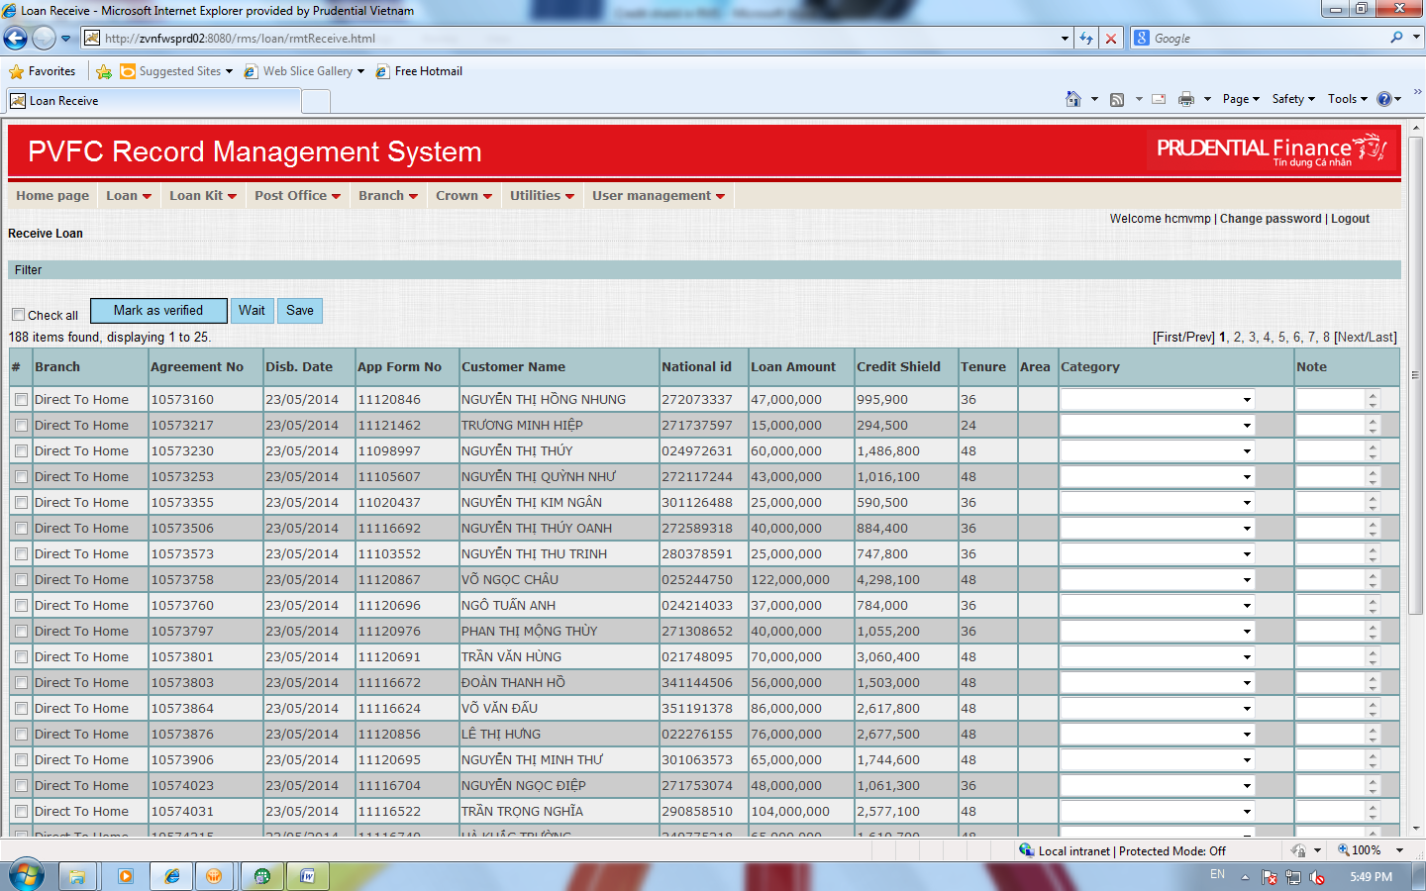

* **Insurance Certificate waiting:**

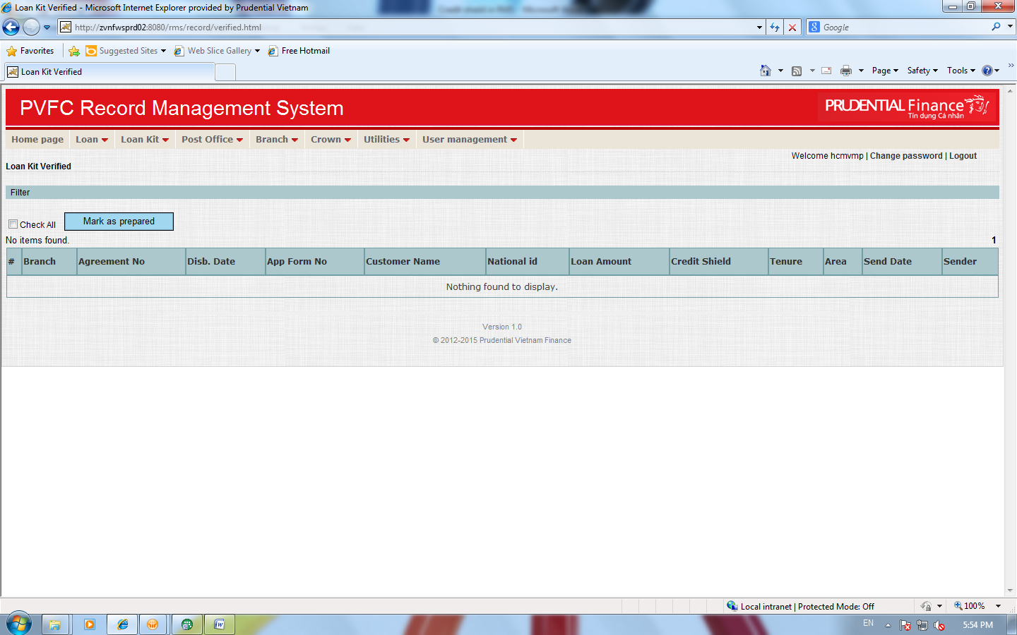

* **Follow-up:**

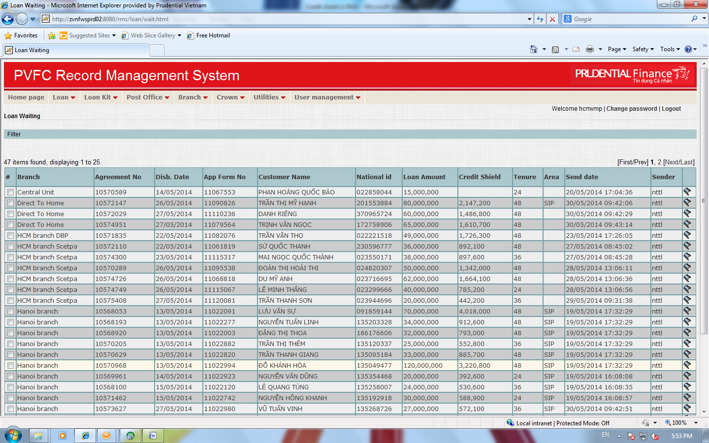

**II/ Functions:**

* Record history: Record all transactions in the lifecycle of loan agreement
* Upload follow-up for Insurance Certificate waiting status: 
* Link Insurance Certificate waiting -> RMS1 + change status: Loan kit prepare (Mark as Done) -> Loan Kit Pending
* Upload to change status from Insurance Certificate waiting & Follow -up -> Insurance Certificate Completed: 
* Link Insurance Certificate Completed -> RMS1 + change status: Loan Kit Pending (Insurance Certificate waiting) -> Loan Kit Ready List (Insurance Certificate Completed)
* Update case by case: Insurance Certificate failure from Insurance Certificate waiting (PVN Decline); follow-up (time out) and Insurance Certificate Completed (Customer cancel)

**III/ Report:**

* List of Credit Shield (sent to PVN)
* Pending – follow-up
* Insurance Certificate waiting
* Insurance Certificate Completed
* Insurance Certificate failure

# Approval

This document has been approved as the official Business Requirements Document for the project.

Following approval of this document, changes will be governed by the project’s change management process, including impact analysis, appropriate reviews and approvals, under the general control of the Master Project Plan and according to Project Support Office policy.

|  |  |  |
| --- | --- | --- |
| Prepared by | Signature | Date |
| **Vo My Phuong**  Assistant Manager, O&T |  |  |
| Reviewed by | Signature | Date |
| **Ngo Ngoc Nga**  Head of Operations | | |
| Approved by | Signature | Date |
| **Luu Ngoc Diep**  Head of O&T |  |  |